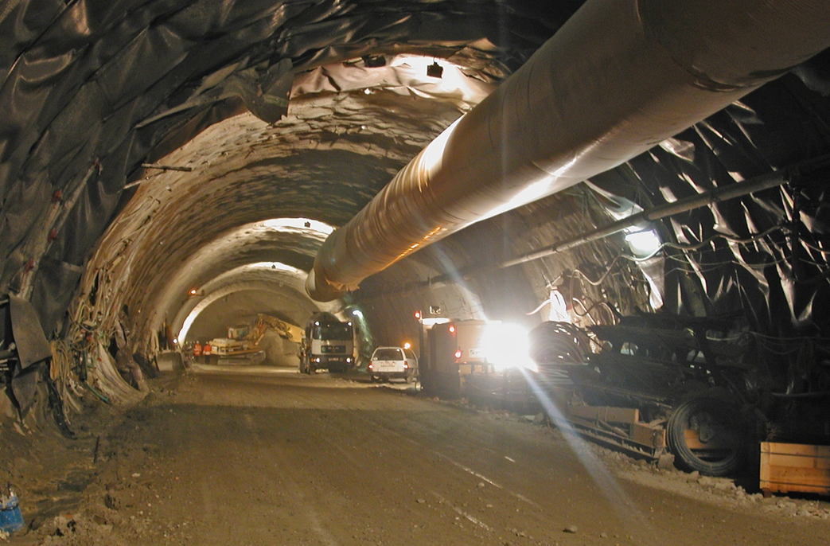

© Robert Galler – MU Leoben

APPLICATION FORM

Master’s programme
NATM Master of Engineering
Construction, rehabilitation and operation of NATM- and TBM-tunnels

Conditions of Application and Cancellation
for the master’s programme NATM, MEng
at Graz University of Technology
current version as of 29 October 2019

The currently valid conditions on application and cancellation apply to admission to and participation in university continuing education programmes at Graz University of Technology (TU Graz). The rights and obligations of the participant regarding individual educational programmes or events can be found in more detail in the specific curriculum as well as in programme or event information and other TU Graz newsletters.

- Application and registration requirements

The application must be submitted in writing by this application form.

The academic direction decides without exception on admission or rejection of applicants. Since only a limited number of students are admitted to the programme, the academic direction reserves the right to select applicants according to academic criteria, to employ a ranking system and to reject applicants. The applicants are selected according to criteria defined in the specific curriculum. Participants will be informed of their admission in writing.

- Data protection

By applying for the programme, the participant gives their explicit consent to TU Graz Life Long Learning to process the data they submit for the purpose of organizing and administering the programme in accordance with the European and national data protection regulations. All data are handled confidentially and are not transmitted to any third party unless it is agreed otherwise or required by law.

With regard to the sending of information and advertising material, we refer to our data protection information: www.tugraz.at/go/LLL-Data-Protection

Consent to receiving information and advertising materials can be withdrawn at any time informally (contact: lifelong.learning@tugraz.at). By signing the application form, the participant confirms that they have read the data protection statement.

- Terms of cancellation

Cancellation of the registration by the participant is possible up to 30 calendar days before the beginning of the programme by means of an explicit communication addressed to the programme management of the programme. The cancellation becomes effective at the time when it is received. In this case, an administration fee of 20% of the total programme fee is charged.

In the event of cancellations later than 30 calendar days before the beginning of the programme, the entire programme fee is due and is not refunded. However, the participant may nominate a suitable substitute. The substitute participant must be nominated before the beginning of the programme and must meet the admission criteria, subject to the adjudication of the academic programme director. The originally registered participant remains liable for the payment of the programme fee until the substitute participant has paid the invoiced fees in full.

In the event that the participant withdraws from the programme for any reason at any time after it has begun, the entire programme fee remains due and is not refunded.

Note: The German language version of this contract is binding and definitive.
This English version is a translation provided for the purpose of information only.

Master’s programme
NATM Master of Engineering, Graz University of Technology
www.natm.at
Email Programme Management:
natm@unileoben.ac.at

Foto

Application form for the master’s programme
NATM Master of Engineering
Start: 11th September 2023

- Personal data

Last name:

First name:

Academic degree:

Date of birth:

Gender: ☐ male ☐ female ☐ non-binary

Citizenship:

B) Address

Home address (street, house number, postal code, city, country):

Telephone number (landline, mobile) / fax / email address:

Postal address (if not same as home address):

C) Education and training

University education (university, university of applied sciences, city, field of study, degree):

Additional qualifications, certificates, job-related education and training:

Language proficiency (foreign language / level):

Computer skills:

Further knowledge and skills:

D) Work experience

Currently employed by (company, agency, line of business, address):

Current job title (position and type of work):

Sonstige einschlägige Berufserfahrungen:

Company | Short description of activities | From month/year | Until month/year

Miscellaneous (stays abroad, research activities etc.):

E) Motivation / Expectations

What is your motivation for participating in this programme?

What do you expect from this programme?

What topics are particularly important to you in this programme?

What personal benefits do you expect to obtain from participating in this programme?

F) Important Information

Your application consists of:

- a completed and signed application form including a photo

- proof of an academic degree

- letters of recommendation and certificates

- copy of passport or identity card

With my signature, I hereby confirm the correctness of the information I have provided on these pages.

Date: Signature:

Programme payment:
☐ Variant 1: The participant will pay 100% of the programme fee out of their own pocket.
☐ Variant 2: 100% of the programme fee will be paid by the company.
☐ Variant 3: % of the programme fee will be paid by the company and % will be paid by the participant. In the event of a cancellation, the company is liable for the participant’s share of the fee.

If the company is paying part or all of the costs, please have the following statement filled out:

G) Company/agency data

A share of % of the programme fees for will be paid by the following company:

Company / Agency / Department:

Contact person (full name / position):

Invoice address (street, house number, postal code, city, country):

Telephone number (landline, mobile) / fax / email address:

VAT number:

I accept the “Conditions on Application and Cancellation” of Graz University of Technology (see page one) and I dispatch the above mentioned person to the Master’s programme NATM MEng.

Date: Signature:

Company’s stamp:

H) For our marketing department

How did you find out about TU Graz Life Long Learning / the programme?

Internet:
☐ TU Graz website
☐ Other website (which one(s)?):
☐ Search engine (which one(s)?):
☐ Social media site (which one(s)?):
☐ Other:

Personal recommendation by:
☐ (Academic) direction, lecturers
☐ Alumni of the programme
☐ Other participant in the programme
☐ Employer
☐ Friend and/or relative
☐ Other:

☐ Information via email
☐ Event (which one(s)?):
☐ I received / came across an informational brochure at:
☐ Advertisement in a newspaper / magazine (which one(s)?):
☐ Article in a newspaper / magazine (which one(s)?):
☐ Other:

☐ I do not consent to receive information and advertising material.

Please submit your application documents to:

Montanuniversität Leoben
Subsurface Engineering
c/o Priv.Doz. Ass.Prof. DI Dr. Nina Gegenhuber
Franz-Josef Strasse 18
8700 Leoben
Tel.: +43 / 3842 402 3407
Email: natm@unileoben.ac.at
www.natm.at

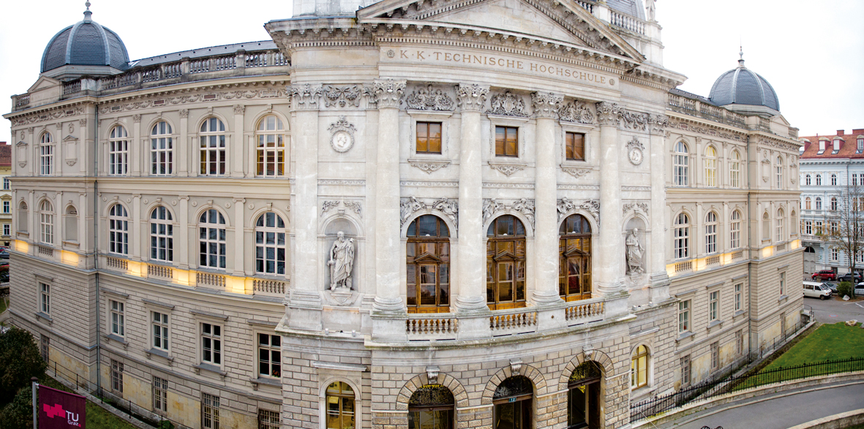
TU Graz

