Abstract template for MHC14
Title up to 2 rows, 14 pt. bold, Times New Roman

FirstAuthor¹, SecondAuthor¹, LastAuthor^{2,}* (12 point)

¹ Department of Physics, University of Old Columbia, Postal Code, City, Country (11 point)
² Department of Chemistry, University of South Pole, NW4 4J2 Quebec City, Norway
* Corresponding author: otto.loewi@south-pole-university.edu [e-mail add. (italicized, in 10-point)]

Abstracts must be submitted electronically, send per mail to mhc14.tugraz.at. Only abstracts accompanied by presentations at the meeting will be published. The submission format is exclusively a Word (.doc/.docx) file. The maximum length of the abstract is one page. Abstracts longer than one page will be rejected.
The template file produces correctly formatted camera-ready abstracts on an A4 page with 30 mm margins. The font should be Times New Roman.
The body of the abstract (Times New Roman, 11pt) should be justified and there should be no blank lines between paragraphs. The first line of the first paragraph should be indented by 0.6 cm. The references (Times New Roman, 10pt), are cited in the text like this¹ etc. The reference list should use the format shown below.
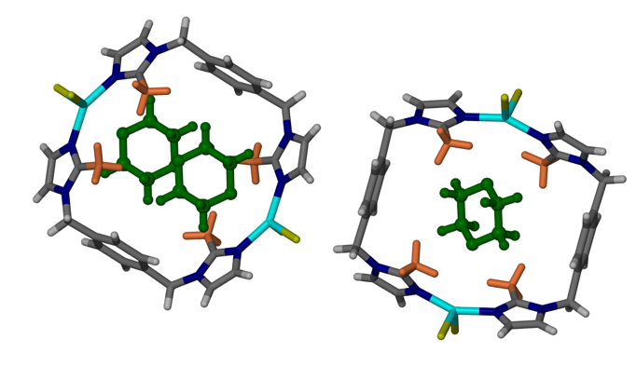
You are encouraged to insert images for visual effect.

(1) First Author, J. C.; Second Autor, S.; Third Author, B. Title of the article. Journal Abbreviation. 2021, 123 (4), 123−321. DOI: 10.1021/acs.0101
(2) please use ACS Style for References

