**[Arial 15, bold] Title of the presentation**

[Arial 12, underline the presenting author] Presenting Author,a,b Further Authorsa

*[Arial 12, italics] a Affiliation a, street, ZIP code city, country; e-mail: xy@xy.at*

*b Affiliation b, street, ZIP code city, country*

[Times New Roman, 13] Please write here the text of your abstract.1,2 The length of the abstract is limited to one page.3

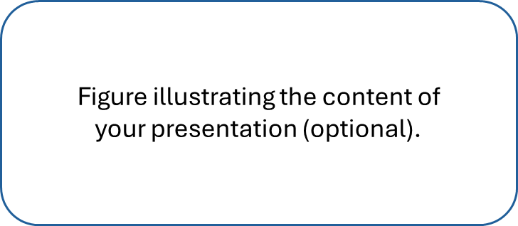

*[Times new Roman, 12, italics] Figure caption.*

[Arial, 11; use ACS style without title – give only the first page number] **References:**

1 Author, X.; Author, X. Y.; Author, Z. Journal name (abbreviated). **2023**, 1, 221.

2 …

3 …