[Arial 15, bold] Carbonization of Macroporous poly(Dicyclopentadiene)-foams

[Arial 12, underline the presenting author] Sebastijan Kovačič.ª Katharina Gruber,^{b} Stefan Koller,^{b} Christian Slugovc^{c,}*
[Arila 12, iltalics] ª National Institute of Chemistry, Laboratory for Polymer Chemistry and Technology, Hajdrihova 19, 1000 Ljubljana, Slovenia
^{b} Varta Micro Innovation GmbH, Stremayrgasse 9, 8010 Graz, Austria
^{c} Graz University of Technology, Institute of Chemistry and Technology of Materials, NAWI Graz, Stremayrgasse 9, 8010 Graz, Austria; e-mail: slugovc@tugraz.at

[Times New Roman, 13] High internal phase templating of surfactant stabilized dicyclopentadiene-water mixtures and subsequent curing via Ring-opening Metathesis Polymerization yields throughout opened macroporous poly(dicyclopentadiene) foams¹ which, upon oxidation, can be pyrolysed yielding macroporous carbon foams of conductivities of up to 2800 Sm⁻¹.² When the pyrolysis is conducted in the presence of carbon dioxide, micro- and mesoporosities are additionally created leading to increased specific surface areas of up to 1100 m²g⁻¹. Similarly, Fe3C/C-foams can be prepared starting from macroporous poly(dicyclopentadiene) γFe₂O₃/Fe₃O₄ nanocomposite foams.³

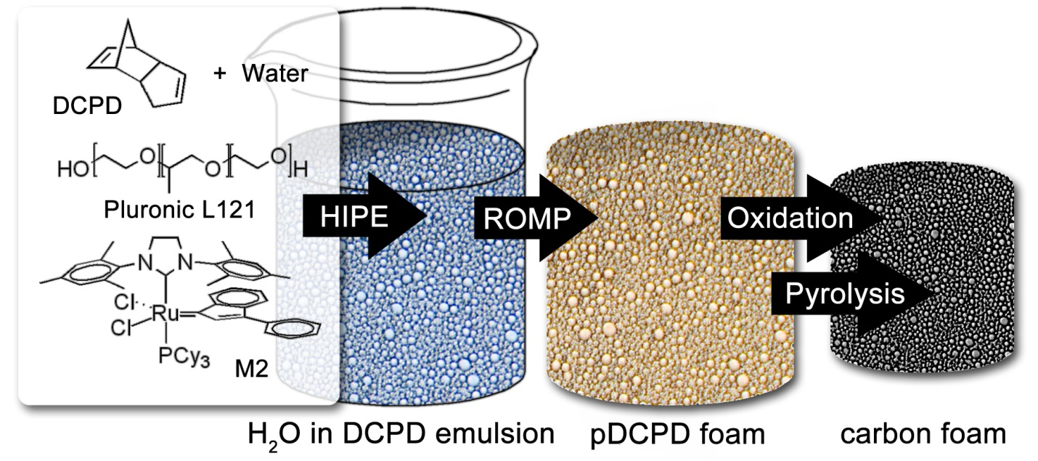

[Times new Roman, 12, italics] Schematic way of preparing macroporous carbon from dicyclopentadiene

References: [Arilal, 11]
1 a) Kovacic, S.; Krajnc, P.; Slugovc, C. Chem. Commun. 2010, 46, 7504; b) Kovačič, S.; Jeřabek, K.; Krajnc, P.; Slugovc, C. Polym. Chem. 2012, 3, 325; c) Kovačič, S.; Matsko, N. B.; Jeřabek, K.; Krajnc, P.; Slugovc, C. J. Mater. Chem. A 2013, 1, 487; d) Kovačič, S.; Preishuber-Pflügl, F.; Slugovc, C. Macromol. Mater. Eng. 2014, 299, 843.
2 Kovačič, S.; Koller, S.; Fuchsbichler, B. ; Scharfegger, M. ; Slugovc, C. WO 2013 178371 A1
3 Kovačič, S.; Matsko, N. B.; Ferk, G.; Slugovc, C. J. Mater. Chem. A. 2013, 1, 7971.

