

Application Form

Master’s Programme
Traffic Accident Research, Master of Engineering

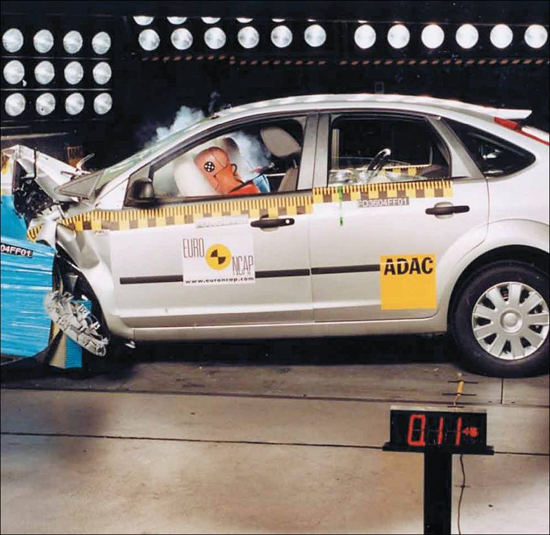



Master’s Programme

Foto
Traffic Accident Research, TU Graz
http://www.LifeLongLearning.tugraz.at
E-Mail: office.vsi@tugraz.at

Application Form for the
Master’s Programme
Traffic Accident Research

Start: February 2016

A) Personal Details

Last name:

First name:

Academic degree:

Date of birth:

Sex:
Citizenship:

Marital status:

B) Address

Home address (street, house number, postal code, city, country):

Telephone number (landline, mobile) / fax / e-mail address:

Delivery address (if different than home address):

C) Education and Training

Formal education after completion of compulsory education (school, city, duration, diploma):

University education (university, university of applied sciences, city, field of studies, degree):

Additional qualifications, certificates, job-related education and training:

Language proficiency (foreign language / level):

Computer skills:

Further knowledge and skills:

D) Work Experience

Currently employed by (company, line of business, address):

Current job title (position and type of work):

Date of joining:

Other relevant work experience (company, type of work, duration):

Miscellaneous (stays abroad, research activities etc.):

E) Expectations / Motivation:

What is your motivation to participate in this programme?

What du you expect from this programme?

What topics are particularly important to you in this programme?

What kind of personal benefits do you expect from participating in this programme?

F) For our Marketing Department:

How did you find out about the University Master Programme?

Internet: http://

Ad in newspaper / magazine:

Press report in newspaper / magazine:

Personal recommendation by:

Other:

G) Important Information:

Your application consists of:

- A completed and signed application form including a photo
- Proof of academic degree
- Relevant letters of recommendation and certificates
- Copy of passport or identity card

With my signature I confirm that I take note of the enclosed terms and conditions of Graz University of Technology.

Date: Signature:

Please submit your application documents in hardcopy form to:

TU Graz
Institut für Fahrzeugsicherheit
z.H. Herrn Univ.-Prof. DI Dr. Hermann Steffan
Inffeldgasse 23/I
A – 8010 Graz

Further information at:

http://www.vsi.tugraz.at

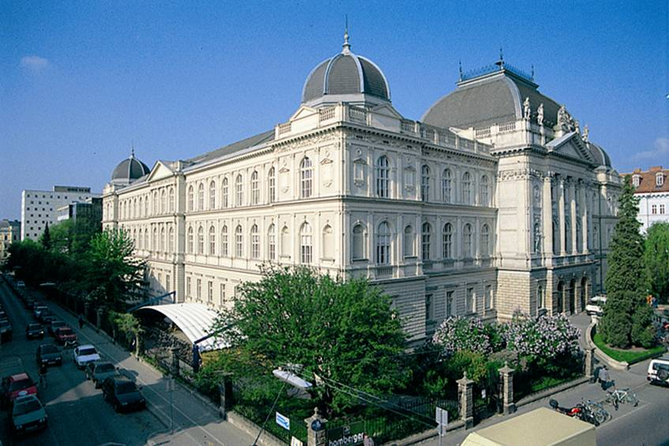

General Contract Terms for University Graduate Programmes
at Graz University of Technology
current version as of 14 May 2013

These General Contract Terms are effective in the respective valid version for admission to and participation in graduate programmes at Graz University of Technology (TU Graz). With regard to the individual educational programmes, workshops and seminars, the rights and duties of the parts of the contract are further determined by the content of the individual curricula of the respective graduated programmes, any information on programmes, workshops and seminars or any other information from Graz University of Technology.

1. Application and registration requirements:

The application is to be submitted in writing and the signed application form is a legally binding registration.
The academic head decides without exception on admission or rejection of applicants. Since only a limited number of students are admitted to the graduate programmes, the academic head reserves the right to select applicants according to didactically appropriate criteria as well as to a ranking. Applicants can also be rejected. Participants will be notified in writing of their university place.

By submitting an application applicants give their express consent to the automation-aided handling and processing of their personal data for the purpose of the graduate programme and exams as well as to receiving future information with regard to professional education. In addition, upon being granted a study place, applicants give their express consent that their names and addresses are passed on to fellow students, lecturers and persons in charge of the organisation of studies in order to facilitate internal communication, and that their names - and if necessary, their pictures - are used as part of marketing and similar activities of Graz University of Technology.

2. Programme fee and payments

The programme fee set for a graduate programme covers the costs for the courses as well as the programme materials. All other costs such as participation in excursions, research as part of the master’s thesis, travel expenses and room and board have to be covered by the participants themselves. At the moment, programme fees are exempt from turnover tax.

The programme fee must be paid in advance for each stage (normally 1 academic year) and is due without deduction within seven days starting from the date of billing. In the case of a delay in payment, the participant will be charged 4% default interest per annum plus reminder fees.

The programme fees are to be paid via bank transfer to the University of Technology Graz by the UniCredit Bank Austria AG – IBAN: AT691200051656101802; BIC: BKAUATWW – and by writing the name of the graduate programme. Any bank charges arising from the transfer must be covered by the participants themselves.

For the length of the graduate programme or master’s programme, participants in the graduate programme agree to use an e-mail account in order to receive information, materials etc., and/or to download this information from an internet address indicated by Graz University of Technology.

3. Terms of cancellation

This graduate programme is a complete education and training system. By registering you are booked for the entire graduate programme.
Participants can terminate the contract (cancellation of registration) exclusively in writing and no later than 4 weeks prior to the beginning of the graduate programme. This cancellation of contract is valid only if it is in writing, sent as a registered letter and if the head of the graduate programme receives the termination within a period of 4 weeks.

Provided that the termination was submitted in time (i.e. no later than 4 weeks before the graduate programme), programme fees that have already been paid will be reimbursed to the participant minus a 20 % deduction for administrative fees.

If the termination is late or if the participant drops out of the graduate programme for whatever reason, the programme fee will not be reimbursed. However, the participant is free to name a suitable alternative participant.

4. Change of services

The services of the graduate programmes or master’s programmes are planned on a long-term basis and undergo constant quality control. Quality assurance requires continuous adjustments. For this reason, Graz University of Technology reserves the right to further develop the curriculum and make changes to the content, days, locations and dates as well as lecturers of courses. These kinds of adjustments, as well as possible changes at short notice, do not entitle participants to withdraw from the graduate programme, to a reduction of programme fees or to claims for compensation.
Any necessary changes, especially of time, location, content or lecturers of individual courses or of the number of participants are the sole responsibility of the head of the graduate programme and do not affect the validity of the rest of the further education contract with the participant.
Graz University of Technology reserves the right to cancel or postpone a course prior to the start of the course and to postpone or cancel the entire graduate programme if there are not enough participants. In the case of a cancellation of an entire graduate programme, 100 % of the fees already paid will be reimbursed to the applicants. However, no further claims will arise from this.

5. Copyright protection

Course content as well as all programme materials handed out to the participants (such as scripts, electronic data carriers, videos etc.) are the intellectual and sole property of TU Graz and are exclusively and solely for the personal use of the participants. Reproduction or any other duplication of the programme materials is only permitted with the express permission of the head of the graduate programme.
All work done by participants as part of the graduate programme remains their own intellectual property. However, participants grant TU Graz the permission to utilise their works in any way possible, free of charge and regardless of time and location, and in particular they grant their express consent that papers (master’s thesis and final papers) selected by Graz University of Technology can be published in parts or in full under the name of the author and in the name of Graz University of Technology in professional publications (magazines, books and internet). The use of the work by the participant is not restricted by this.

6. Liability for objects and house regulations

The knowledge acquired and applied from the graduate programme does not substantiate any liability claim on Graz University of Technology. Liability for injuries sustained during the graduate programme is excluded from the realm of legal possibilities. Liability for slight negligence, compensation for consequential and economic or financial loss, lost profit and damages resulting from claims of third parties are excluded, too. All participants in the graduate programme are responsible for their own decisions and actions.
Graz University of Technology assumes no liability for the theft, loss or damage of objects brought to the graduate programme, and in particular valuables.
The house regulations of Graz University of Technology are valid in their current version. A repeated violation of the house regulations or other safety regulations of Graz University of Technology leads to the exclusion of the participant from further participation in the graduate programme; in this case there is no reimbursement of the programme fee.

7. Miscellaneous, court of jurisdiction and validity

These General Contract Terms are valid for all graduate programmes that take place at Graz University of Technology. If individual conditions of these general terms and conditions are or become invalid, the remaining parts of the general terms and conditions are not affected. Subsidiary agreements have to be in writing and need to be approved by both contract parties in order to be valid.
Graz is the exclusive court of jurisdiction for all disputes resulting from the contracts concluded between Graz University of Technology and its contractual partners. This contract shall be governed by and construed in accordance with the laws of Austria, without giving effect to the principles of conflicts of law applicable under Austrian Private International Law.

Graz University of Technology
14 May 2013

