First name and surname, academic degree

Title of thesis

Master’s thesis
to achieve the academic degree of
Diplom-Ingenieur
Master’s degree program: Mechanical Engineering and Business Economics

submitted to

Graz University of Technology

Supervisors
Name of supervisor(s)

Institute of Innovation and Industrial Management
Univ.-Prof. Dipl.-Ing. Dr.techn. Christian Ramsauer

Graz, January 2017

Affidavit

I declare that I have authored this thesis independently, that I have not used other than the declared sources/resources, and that I have explicitly indicated all material which has been quoted either literally or by content from the sources used. The text document uploaded to TUGRAZonline is identical to the present master‘s thesis dissertation.

…………………………… |  | ….……………………………………………
Date |  | Signature

Acknowledgement
Add text

Abstract
Add text

Kurzfassung
hinzufügen
Table of Content
Acknowledgement III
Abstract IV
Kurzfassung V
1 Introduction 1
1.1 Objectives 1
1.2 Sample Reference Definition Technology 1
1.3 Structure of the Thesis 1
2 Theoretical Input 2
2.1 Headline 1 2
2.1.1 Sub headline 1 2
2.1.2 Sub headline 2 2
2.1.3 Sub headline 3 2
2.2 Headline 2 2
3 Practical Part 3
4 Conclusion and Outlook 4
References 5
Online References 6
List of Figures 7
List of Tables 8
List of Abbreviations 9
Appendix A: name 10

Introduction
Sample text.

Objectives
Add text

Sample Reference Definition Technology

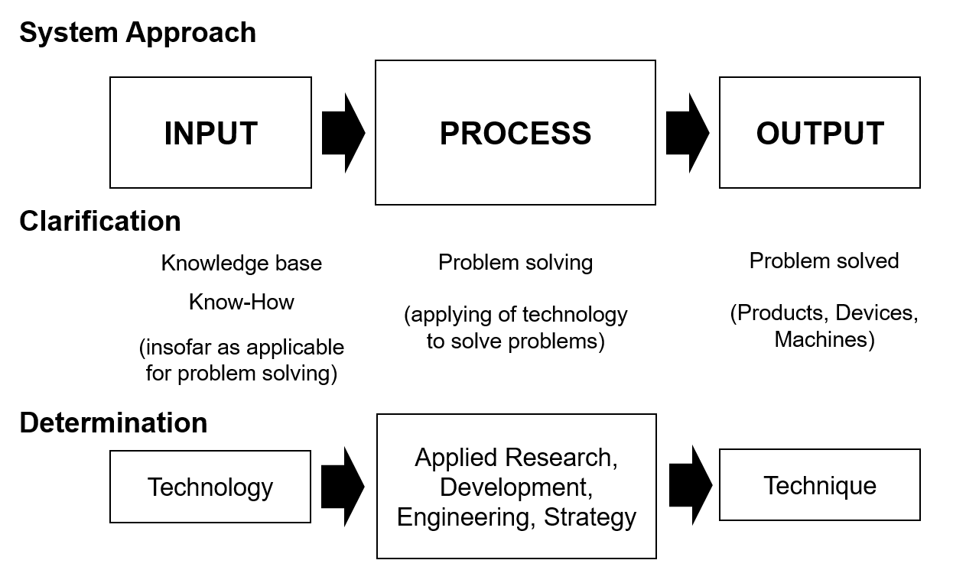
Figure 1: Definition technology and technique

Structure of the Thesis
Add

Theoretical Input
Add text

Headline 1
Add text

Sub headline 1

Sub headline 2

Sub headline 3

Headline 2
Add text

Practical Part
Add text

Table 1: AngelList data
Criterion | Companies | Investors | Followers
Number | 19986 | 24270 | 26008

Conclusion and Outlook
Add text

References
Ardilio, A.: Fraunhofer TechnologieRadar: Trends erkennen – Technologien umsetzen, in: Bullinger, H.-J.: Fokus Technologiemarkt, Technologiepotenziale identifizieren – Marktchancen realisieren, München 2012a

Bruhn, M.: Marketing – Grundlagen für Studium und Praxis, 5th edition, Wiesbaden 2001

Bullinger, H.-J.: Einführung in das Technologiemanagement, Stuttgart 1994

Online References
AngelList: Startup platform, https://angel.co/?ref=nav, request of 04.09.2016

Austrian Angel and Investor Association: About the Austrian Angel and Investor Association, http://www.aaia.at/de/ueber-uns/wer-sind-wir/, request of 14.11.2016

List of Figures
Figure 1: Definition technology and technique 1

List of Tables
Table 1: AngelList data 5

List of Abbreviations
BCG Boston Consulting Group
Cf. Confer

Appendix A: name

Cf. Bullinger (1994), p.33-34
ibidem

