this is the best title for my Seggau manuscript
A. Aristoteles*, I. Kant* and A. L. L. Others**
*University of the Inner Orbit **Wherever one may work or live (1. Company name 2. Area code 3. City 4. Country 5, Orcid Id if available 6. e-mail address – in this order)
Abstract
The Institute for Materials Science and Welding, Graz, University of Technology looks forward to welcoming you to the next conference on Numercial Analysis of Weldability in Graz, Seggau. In order to facilitate the authoring process, the IMAT provides to you an MS Word document, which includes instructions how to format your paper and an example of a template as well, containing nearly all styles you need for laying out your document. Using these styles will keep your effort to prepare the required page layout to a minimum and will ensure a smooth editing of the conference proceedings. Please read the instructions carefully. If you have any questions don’t hesitate to write an e-mail to Bettina Foessl (bettina.foessl@tugraz.at).
Keywords: (please keep an empty line between Abstract and Keywords)

Introduction to This Document
This document outlines how your Seggau manuscript for the conference 'Numercial Analysis of Weldability’ should look like.
You may
- either directly copy your text into this document and apply the necessary styles for each element to it
- or you can save the template to your template directory and apply it to your document. Don’t forget to change the page size as well!
- or format your document (or parts of it) completely on your own. In this case please ensure that it really looks like this sample, otherwise it will cause major layout revisions and may be returned to you.
Please note that we are not using regular A4 format, but smaller, a user-defined page size. For the correct paper size, the margins and headers/footers see the menu ‘file’ – ‘page setup’. In the subsections ‘margins’, ‘paper’ and ‘layout’ you can find the correct values.
To open and use the style templates which are connected to this document go to the menu ‘format’ | ‘styles and formatting’. The available style templates usually appear at the right side of this document. Most elements are self-explanatory.
Normally styles are applied by placing the cursor into the concerning paragraph and clicking the desired style. Only for the ‘character’ styles you have to mark the parts of the text first and click the desired style afterwards.

Elements of your manuscript (capital letters, TIMES NEW ROMAN 11)

Title, authors and abstract (small capitals, times new roman 10,5, only the first letter of the whole line is written in capital letter… all other words start with a small letter or small capitals)
- Title Use this style template for the title of you document.
- Authors – Names use for name(s) of the authors. Put a space between authors' initials.
- Authors – Addresses Use this style for the addresses of the author(s). Indicate different addresses for different authors e.g. by *, ** etc.
- Abstract – Heading and Abstract – Text Use this format for your abstract. In the abstract a smaller font size is used.

Formatting headings and paragraphs (small capitals, times new roman 10,5, only the first letter of the whole line is written in capital letter… all other words start with a small letter or small capitals)
The font for the entire document is ‘Times New Roman’, font size in the normal text is 10.5 points. Normal text should be justified to both the left and right margins.
The first paragraph in each chapter has no indentation on the first line (use Text – first Paragraph), every following has one (use Text). Don’t use empty line spacing between the paragraphs. If for any reason you want to break a line without starting a new paragraph, then press Shift and Enter simultaneously. For enumerations we have prepared an enumeration style containing bullets, but feel free to use your own if you want to do so. There are three different headings, we think that a fourth one shouldn’t be necessary.

first (capital letters, Times new roman 11)

Second (Small capitals; times new roman 10,5)

Third (italic, Times new roman 10,5)
On top of all even pages, the title of your document should occur. You can do this by double clicking on the header and changing the inserted text ‘title of your paper’.

Formatting tables
Insert your table and format it as given in the example below. Some styles for doing so are available as style template (see the Table styles), some formats (e.g. the boundaries – line width is ½ point) you will have to do manually using the ‘Table’-menu. Table 1 shows an example of the style of tables be used for the conference proceedings.
Table 1 Captions of a table are always above the table (this line format in justified text)
Seggau 1999 | Seggau 2001 | Seggau 2003 | Seggau 2006
Many | Styrian Evening | Mathematical | Welcome
Scientists | Styrian Wine | Modelling | at
Much | Carinthian Singing | of | Seggau
Research | Austrian Dancing | Weld Phenomena | 2006!

Formatting figures
Use a separate paragraph for your figure to insert (Figures – Paragraph). Figures captions (Figures – Caption) are always beneath, for highlighting the word ‘Fig.’ mark it separately and use Figures – Caption ‘Fig. x’. 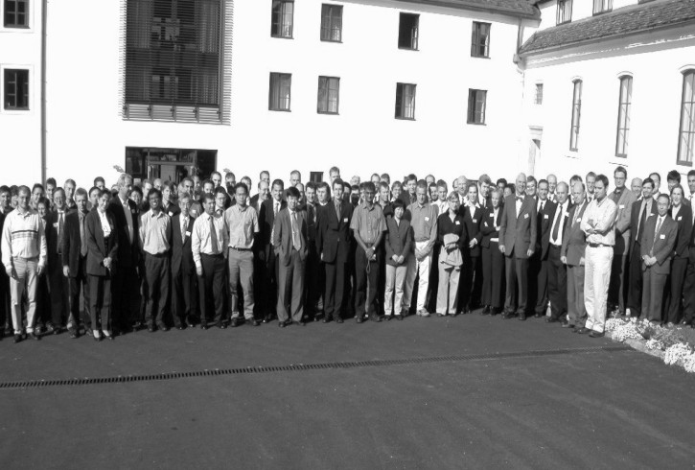
centred, placed in the middle
Fig. 1 Delegates of the Seventh International Seminar held October 2003 in Seggau. (formatted in justified text with a full stop at the end, the same when a chart is used)
Figures are always placed in the continuous text, not in a separate section at the end of the document. Do not put borders around your figures. Take care to provide only illustrations in sufficient quality! Keep in mind that publication will be in black and white only!
Important note: we can accept all pictures and figures only as single embedded images. Do not use drawing tools provided by MS Word or similar to draw inside your document. It must be possible for us to resize each picture ‘as it is’ without the necessity to edit the image afterwards. Please consider this point as very serious, some formats can produce very strange things during layout and are causing serious problems to us. Ignoring this rule could make it possible for us to send the paper back to you for revision!

Formatting references
For references, we use square brackets [1], please note that these are always [1] placed before punctuation marks [1]. If you directly refer to Ref. [4-5] also use square brackets. The references should be numbered in order of appearance. Authors are written in capitalized letters, the title of the cited article is written in quotation marks ‘like this’. The journal containing the article or a book is written in cursive style. Numbers of the issue or edition are formatted in bold letters. Each reference ends with a full stop. You can find an example list (References – Listformat) at the end of this document.

Some Remarks on Maths Style
This section shortly deals with the representation of physical units and mathematical characters within the text and the formulas.

Writing equations
For writing your equations please use the ‘Microsoft Equation Editor’. You can either directly insert a new formula (‘insert’ | ‘object’) or copy and edit one of the following examples.
There are rules for formatting mathematical elements, here are some basic ones:
- Scalars/variables/indices: cursive
- Vectors: either cursive with an arrow on top or bold only
- Predefined functions as exp(x), sin(φ) etc: normal
- Numbers: normal
- Brackets: normal
In the following example
${\vec{a}}_{1}=\frac{{\text{dv}}_{1}}{\text{dt}}\vec{e}$, $\vec{e}=\left(\begin{matrix}e_{x} \\ e_{y} \\ e_{z}\end{matrix}\right)$, $e_{x}=\text{sin}(ϕ)$ (1)
some of these rules are demonstrated. Notice that the line following an equation should not be indented unless it is meant to start a new paragraph. You can handle this e.g. by formatting this paragraph as a ‘first Paragraph’. Equations are considered to be part of a sentence and should be punctuated accordingly. Principal equations are numbered, with the equation number placed within parentheses and right justified.

Another Example
$a_{1}=\frac{{\text{dv}}_{1}}{\text{dt}}e$, $e=\left(\begin{matrix}e_{x} \\ e_{y} \\ e_{z}\end{matrix}\right)$, $e_{x}=\text{div}b=∇b$ (2)

Formulas in text
Remember that all mathematical elements which appear in the text have the same format as in the formula. In Eqn. (1), $\vec{a}$ denotes the acceleration, v the velocity and t the time. Numbers and units normally are separated by a space (λ = 600 nm, T = 500 °C, except a = 40%) and units are always written in normal style (not cursive), e.g. welding conditions are I = 200 A, U = 25 V and v = 3 m s-1. The same holds for chemical declarations (e.g. Cr) and phase fractions (e.g. γ-phase). For denoting dimensions, use the sign × if available on your system (e.g. 150 × 150 × 6 mm).
Appendices and Acknowledgements
The text is formatted as in all other chapters of your paper.
Please submit the first version of your manuscript in pdf format via our Conference Management System. This version will be sent to the peer reviewers. You will then be notified and details will be given how to send in your final version in MS Word format. Please keep to the deadlines which you can find on our homepage http://imat.tugraz.at.
Finally, we look forward to welcoming you at the next conference ‘Numercial Analysis of Weldability’ in Seggau!

References

[1] N. Kopernikus: De Revolutionibus Orbium Coelestium, Nürnberg, 1543.
[1] S. Omeone and S. O. Meone: ‘Some paper with some title about something’, some Journal or Book, Vol. 1, No. 1, pp. 753-777, somewhere, 2022.
[2] H. Cerjak: ‘Title of a paper’, Mathematical Modelling of Weld Phenomena 8, Verlag der Technischen Universität Graz, pp. 123-321, 2005.
[3] Ph. D. Student: There’s another call for papers for a conference in H, thesis, School of Engineering, University of Hawaii, 2005.
formatted in justified text, and full stop at the end.

