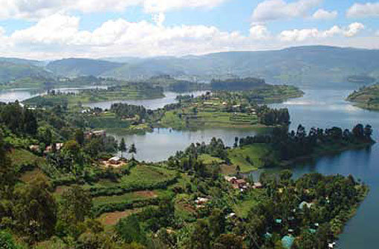
Ethiopia
Uganda

Master thesis in Environmental Biotechnology
We are looking for a master student interested in Biotechnology, Microbiology and Plant Sciences for our project funded by the Austrian Development Agency:

Healthy seedling systems for safer, more productive

vegetables in East Africa

This project aims to deliver the concept of using healthy seedlings to smallholder vegetable farmers in Uganda and Ethiopia as a basic principal, and further undertake research to evaluate improvements to this basic intervention for local suitability and acceptance. Our contribution to the project are i) microbiome research on vegetables grown in Africa, and ii) development of microbial inoculants for healthy vegetable seedlings.
Partners: CGIAR center: International Institute of Tropical Agriculture (IITA), Makerere University (MU), Uganda, University of Addis Ababa, Ethiopia
If you are interested in this topic, please contact: Gabriele.berg@tugraz.at
Institut für Umweltbiotechnologie, TU Graz, Petersgasse 12, www.ubt.tugraz.at

Fotos: Kraufmann, Getty images

